John Michael Go
Career Entry Level Java Programming
Date: Jan. 18, 2013

DAY 6

Program Name: Checking Account Balance

Objective: Program will output data in a different file and in a user readable format.

Algorithm:

1. Program searches for a file and outputs data is a separate file in a user readable format.

Flowchart:
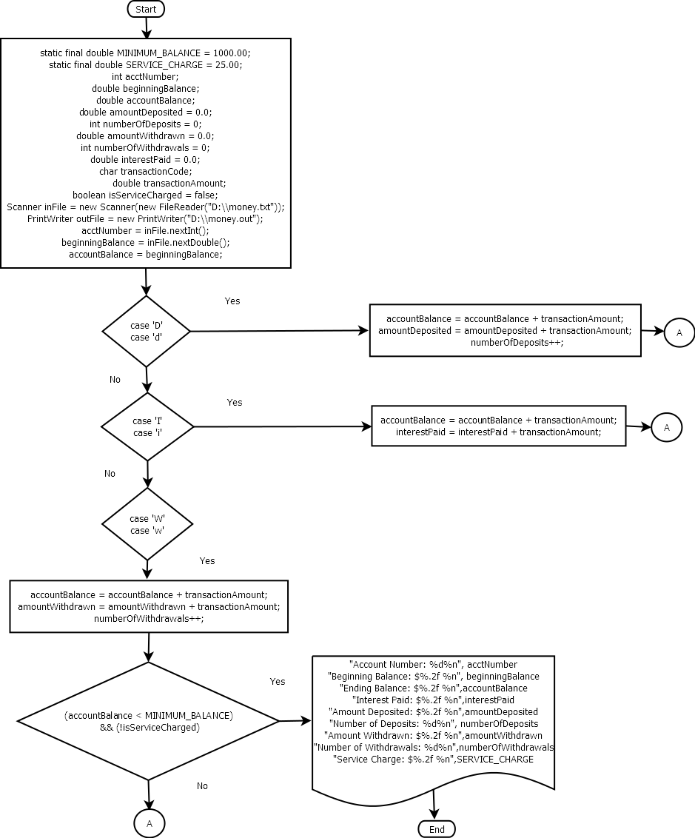

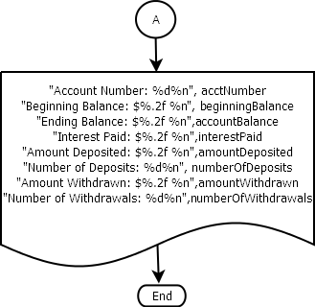

Pseudocode:

import java.util.*;
import java.io.*;

public class CheckingAccountBalance {
static final double MINIMUM_BALANCE = 1000.00;
static final double SERVICE_CHARGE = 25.00;

public static void main(String[] args) throws IOException,FileNotFoundException
{
//Declare and initialize the variables //Step 1
int acctNumber;
double beginningBalance;
double accountBalance;
double amountDeposited = 0.0;
int numberOfDeposits = 0;
double amountWithdrawn = 0.0;
int numberOfWithdrawals = 0;
double interestPaid = 0.0;
char transactionCode;
double transactionAmount;
boolean isServiceCharged = false;
Scanner inFile = new Scanner(new FileReader("D:\\money.txt"));
PrintWriter outFile = new PrintWriter("D:\\money.out");
acctNumber = inFile.nextInt();
beginningBalance = inFile.nextDouble();
accountBalance = beginningBalance;

while (inFile.hasNext())
{
transactionCode = inFile.next().charAt(0);
transactionAmount = inFile.nextDouble();
switch (transactionCode)
{
case 'D':
case 'd': accountBalance = accountBalance + transactionAmount;
amountDeposited = amountDeposited + transactionAmount;
numberOfDeposits++;
break;

case 'I':
case 'i': accountBalance = accountBalance + transactionAmount;
interestPaid = interestPaid + transactionAmount;
break;

case 'W':
case 'w':
accountBalance = accountBalance + transactionAmount;
amountWithdrawn = amountWithdrawn + transactionAmount;
numberOfWithdrawals++;

if ((accountBalance < MINIMUM_BALANCE) && (!isServiceCharged))
{
accountBalance = accountBalance + SERVICE_CHARGE;
isServiceCharged = true;
}
break;
default: System.out.println("Invalid transaction " + "code.");
}
}

outFile.printf("Account Number: %d%n", acctNumber);
outFile.printf("Beginning Balance: $%.2f %n", beginningBalance);
outFile.printf("Ending Balance: $%.2f %n",accountBalance);
outFile.println();
outFile.printf("Interest Paid: $%.2f %n",interestPaid);
outFile.println();
outFile.printf("Amount Deposited: $%.2f %n",amountDeposited);
outFile.printf("Number of Deposits: %d%n", numberOfDeposits);
outFile.println();
outFile.printf("Amount Withdrawn: $%.2f %n",amountWithdrawn);
outFile.printf("Number of Withdrawals: %d%n",numberOfWithdrawals);
outFile.println();

if (isServiceCharged)
outFile.printf("Service Charge: $%.2f %n",SERVICE_CHARGE);
outFile.close();
}
}

Screenshot:
